- Purpose
  - The purpose of this document is to describe the procedure for quality checking a Bertha Strip Machine.
- Scope
  - This SOP applies to all equipment assembly team members. The process applies to the following machines:
E012327EQM0600BE1200 – Big Bertha XSM30 Propane Stripping Machine Pkg
E088398EQM0600BE1200 – Lil Bertha XSM24 Propane Stripping Machine Pkg

- Responsibilities
  - The operations manager/supervisor is responsible for enforcing this SOP.
- Materials
  - Tachometer
- Definitions

- Procedure
  - This test needs to be performed on smooth concrete.
  - Check the machine over and see if there are any visual issues with the machine (Dirt, loose wires, parts missing, etc.). Verify that the machine is not riding on the transport wheel. If it is, remove it. The brushes need to be on the floor for the test.
  - Install, connect, and open the valve of a test propane tank.
  - Connect the tachometer to one of the spark plug wires.

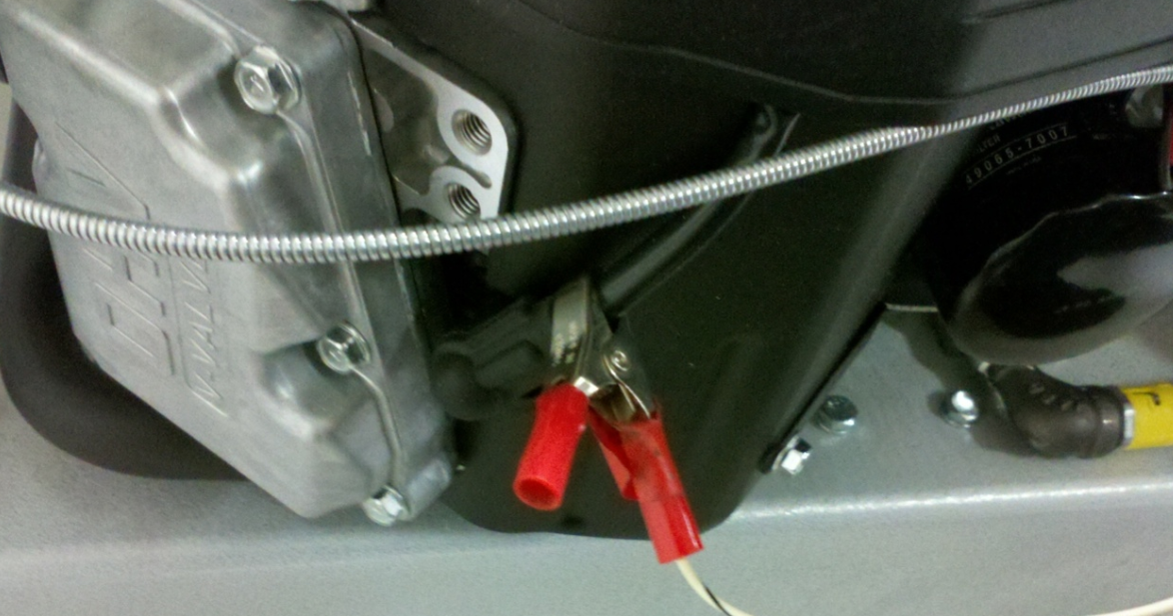

  - Start the engine and set the throttle speed to the idle position.

  - Set the idle RPM of the engine. It should be set to 1800rpm. This is done by adjusting the idle adjustment screw shown in the photo below. Be sure to tighten the nut back up when complete. The engine may spit and sputter a little at first. It needs some time to warm up.

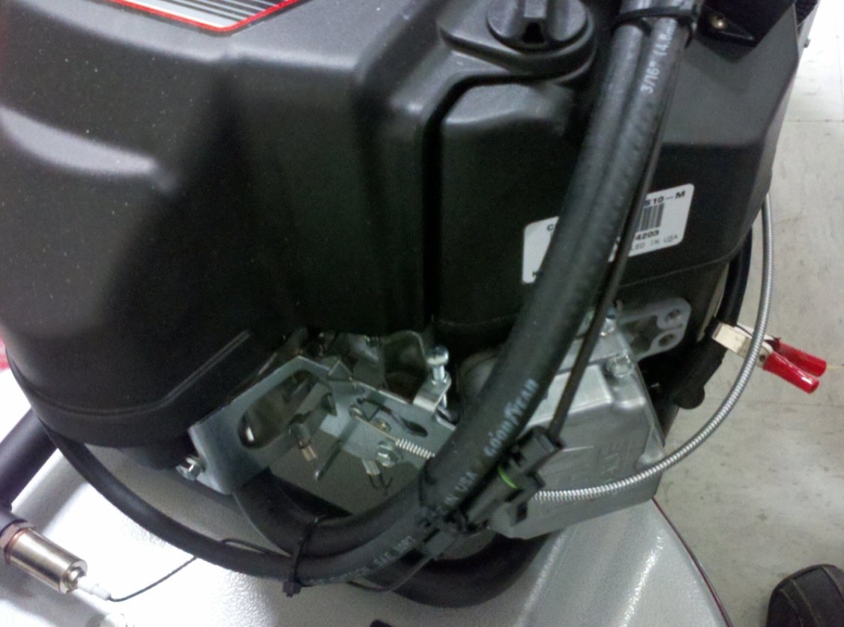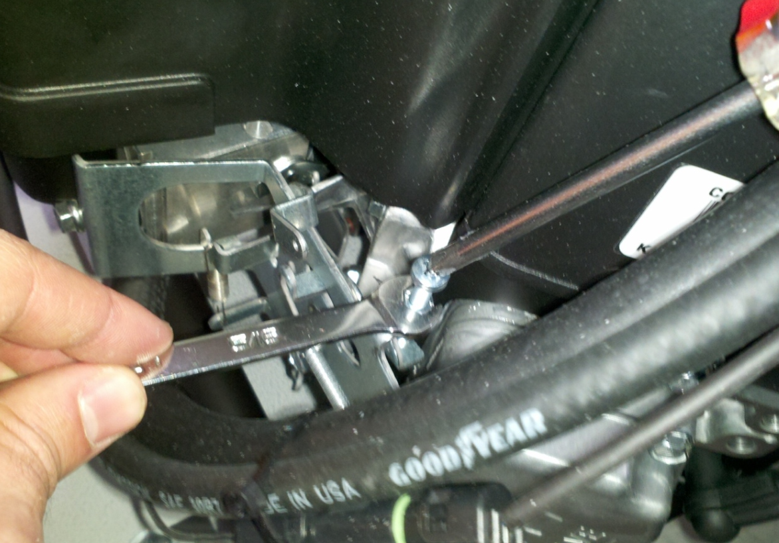

  - Hold onto the machine and ramp the engine up to full throttle. It should be around 3600 rpm. If adjustment is needed, it can be done using the screw circled in the photo below. Threading the screw out will increase the RPM’s. Be sure to reset the throttle cable whenever an adjustment is made here.

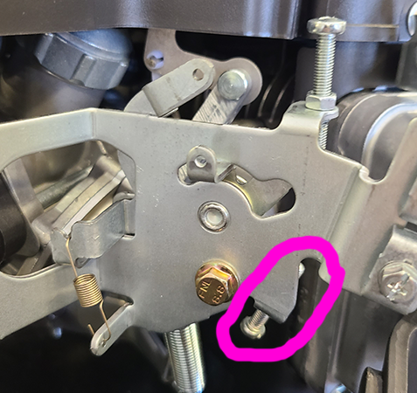

  - Operate the machine in its intended manor for 1-2 minutes and note any abnormalities in handling, engine sounds, etc. If anything is noted, return it to the assemble team for adjustment.
  - Put the throttle back into the idle position. Double check the RPM’s at this point as it may need to be re-adjusted back to 1800rpm.
  - Once that is complete, shut the machine off and remove the test propane tank.
  - Put together a manual packet for the machine. This includes a machine manual, a Kawasaki engine manual, a Kawasaki Warranty form, a Betco warranty registration card, and a tech service card. This should all be put in a bag and shipped with the machine.
  - Stage the machine for packaging.

- References (optional section as needed)

- Training Guide

Functional Training Groups Requiring Training

- SOP Change Control

Date of Change | Reason for Change
Rev 01 - 11/18/2013 | This is the first version of the S.O.P. hence there are no revisions to this document.
Rev 02 - 1/18/2018 | Added the Responsibilities Section
Rev 03 - 3/14/2025 | Updated for Onyx engine

Approvals

Submitter/Author Approval:__________________________________ Date:______________________

Management Approval:______________________________________ Date:______________________

QAU Approval:_____________________________________________ Date:______________________

